ROTAG – Rotaract Club of Tagore Dental College & Hospital
Sponsored by Rotary club of Madras Northwest
RID 3232 – Group 9
3rd – Installationceremony
Date : 19.08.2021. – Thursday
Time : 11.30 AM – 1.00 PM
Platform : Hybrid – Google meet
Chief Guest : Rtn.R.Ravi Shankar – District Rotary secretary 2021 – 22
Guest of Honour : Dr.C.J.Venkatakrishnan– The Principal -Tagore dental college & Hospital
District Rotaract Officials –
Rtr.PP.Kamuvel – District Rotaract Representative
Rtr.PP.Dineshkumar – District Rotaract Secretary ,
Rtr.PP.Adhithya – Group Rotaract Representative – Group 9
Rotarians attended : 10
RotaractorsAttened : 45- Board officals of the year 20-21 & 21-22 In college auditorium ,168 -1St and 2nd year - Attend in Google meet
Staffs Attended: 10
Link – http://meet.google.com/fbn-ommf-nit

AGENDA FOR INSTALLATION CEREMONY

MC: Rtr. Felcy
- 11:30 a.m - Introduction to programme by M.C
- 11:31 a.m - Collaring the President of RC Madras Northwest Rtn. C.H.Mukesh by the secretary Rtn. Subramaniam
- 11:32 a.m - Colloring of President Rtr. Tannish Thangavel by SAA Rtr. ShyamSundar and Meeting call to order by Rtr. Tannish Thangavel
- 11:33 a.m - Rotaractprayer By .Rtr.DeepikaBharathi
(Modulated by MC)
- 11:36 a.m - Welcome address by Dr. Kumara Raja by MC
- 11:38a.m - Introduction of Guest of Honour The Principal Dr. C.J.Venkatakrishnan by MC
- 11:39 a.m - Address by The Principal Dr. C.J. Venakatakrishnan
- 11:43a.m - Introduction of the Vice Principal Dr. S.Balagopal by MC
- 11:44 a.m - Address by the Vice Principal Dr. S.Balagopal
- 11:47 a.m - Introduction of the Vice Principal Dr. S.Jimson by MC
- 11:48 a.m - Address by the Vice Principal Dr. S.Jimson
(Modulated by MC)
- 11:52a.m - Sharing experiences as The President of the rotary year 2020-2021 by Rtr. Tannish Thangavel
(Modulated by MC)
- 11:55 a..m - Secretary report on the last year activities by Rtr. JananeeBharkavi (Modulated by MC)
(Modulated by MC)
- 12:02 p.m - Exchange of collor by Rtr. Tannish Thangavel to Rtr. JananeeBharkavi
- 12:03 p.m - Acceptance speech and oath taking by the President Rtr. JananeeBharkavi
(Modulated by MC)
- 12:08 p.m - Handing over the charter to the secretary Rtr. Harris by the out going secretary Rtr. JananeeBharkavi
- 12:10p.m - Introduction of Directors by the President RtrJananeeBharkavi .
- 12:13 p.m - Oath taking by the Board Officials
(Modulated by MC)
- 12: 15p.m - Speech by RtnC.H.Mukesh of RC Madras Northwest
(Modulated by MC)

- 12:17 p.m - Address by Rtn. Subramanian Secretary RC Madras North West
(Modulated by MC)
- 12:19p.m - Address by Rtn. Bharath Youth Services Director RC Madras North West
(Modulated by MC)
- 12:21 p.m - Speech by DRR PP. Rtr. Kamuvel .
(Modulated by MC)
- 12:22 p.m - Speech by DRS. PP. Dinesh kumar.
- 12:23p.m - Introduction of Chief Guest Rtn. Ravi Shankar, District Secretary by Rtr. (Any one of the directors)
- 12:24 p.m - Speech by Rtn. Ravi Shankar, District Secretary
- 12:49 p.m - Felicitations of Rtn. Ravi Shankar, District Secretary (Moderated by MC)
- 12:50 p.m - Vote of thanks by the secretary Rtr. Harrish
- 12:53 p.m - Meeting will be adjourned by Rtr. JananeeBharkavi

MINUTES OF THE MEETING

Introduction to the Installation Ceremony was given by Emcee.Dr.Felcy, Collaring of Rtn.C.H.Mukesh – President of Rotary Club of Madras Northwest By Rtn.Venkateshwaran , Rotary club of Madras Northwest followed by collaring of President Rtr.Tanish Thangavel by SAA Rtr.Shyam sundar and Meeting was called to order.
Rotaract Prayer was rended by Rtr.Deepika Bharathi. The Welcome address was given by Dr.Kumara Raja – Student co-ordinator. Introduction to Guest of Honour Dr.C.J.Venkatakrishnan by MC. Principal Dr.C.J.Venkatakrishnan Addressed the meeting, Followed by Addressing of Vice principals – Dr.Balagopal and Dr.S.Jimson,
The outgoing President Rtr.Tanish Thangavel Shared his rich experience of the year 20-21. The secretarial Report was given by outgoing secretary Rtr.Jananee Bharkavi ,Exchange of Collar by Rtr.TanishThangavel to Rtr.Jananee Bharkavi, acceptance speech and Oath taking by the President and handing over of the charter by Rtr.Jananee Bharkavi to Rtr.Harris.j
Introduction of the Board officials of the year 2021-22 President Rtr.JananeeBharkavi and the Oath taking of the board officals was taken, And Speech By Rtn.C.H.Mukesh – President, Rtn.Subramanian - Secretary ,Rtn.Bharath – Youth Service Director of RC of Madras Northwest ,Rtr.PP.Kamuvel –District rotaract Represntative , Rtr.PP.Dinesh kumar District Rotaract Secretary.
Introduction to Chief Guest was given by Rtr.Rakshana ,Speech by the Chief Guest Rtn.R.Ravi Shankar – District Secretary and the felicitation of the chief guest, President , Secretary Of RC of Madras North west,District Rotaract officials was done,Vote of thanks for the Installation was given By Rtr.Harris.J and the Meeting was adjourned by the President Rtr.Jananee Bharkavi

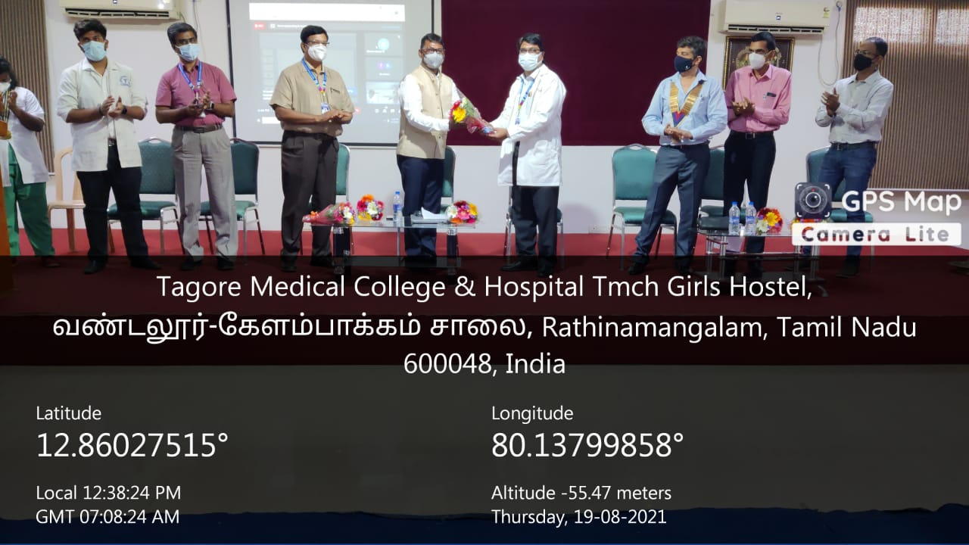
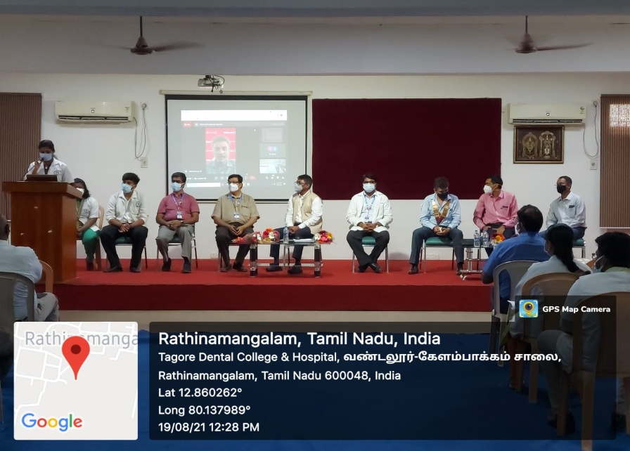
PHOTO GALLERY
Dignitaries on the dias
Welcome of Chief guest by Principal

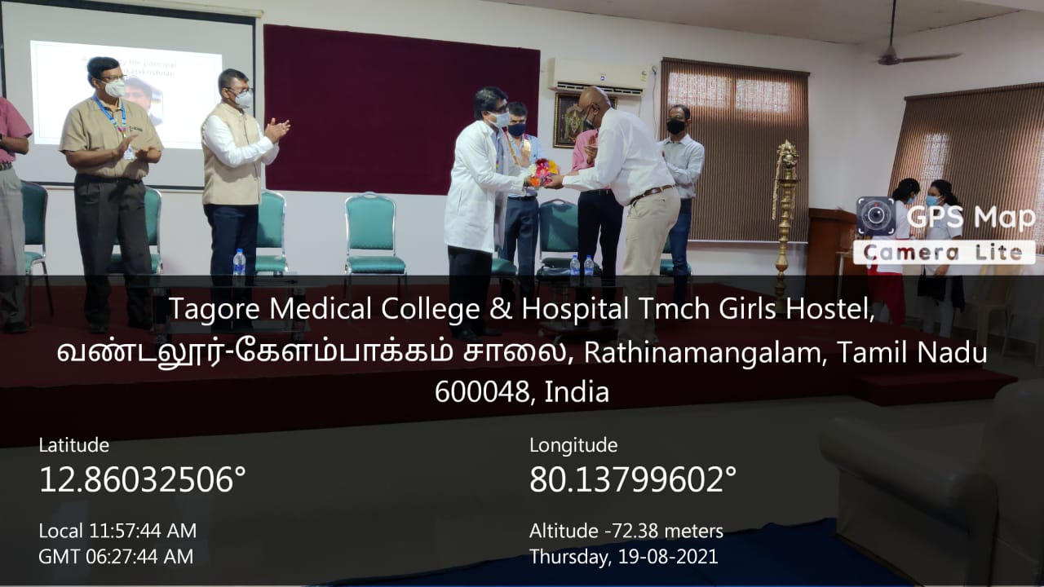
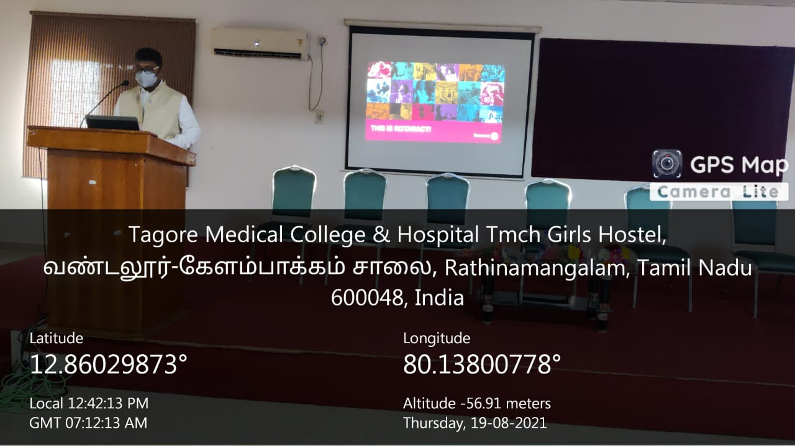

Honouring of Rotary member by Principal
Address by the Chief guest Rtn.R.Ravi Shankar

PHOTO GALLERY
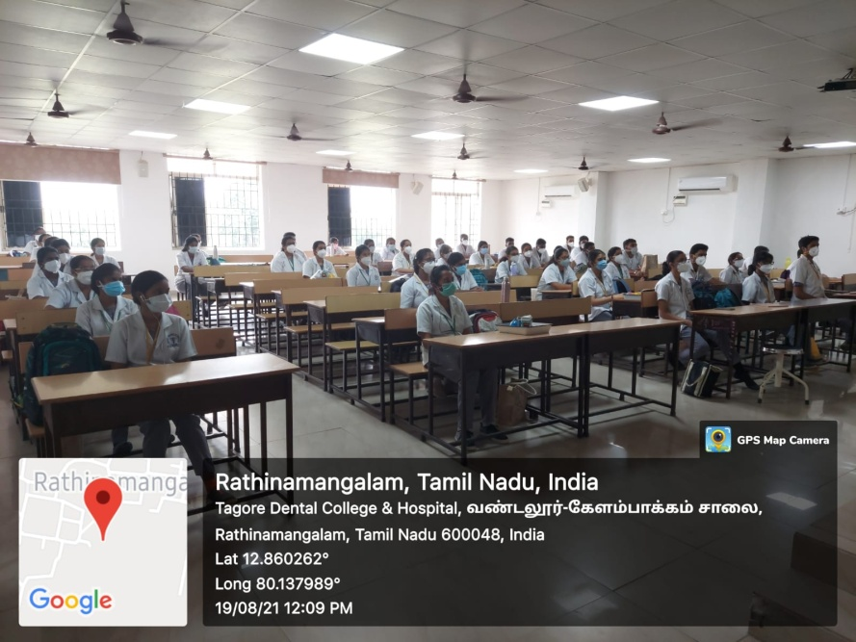
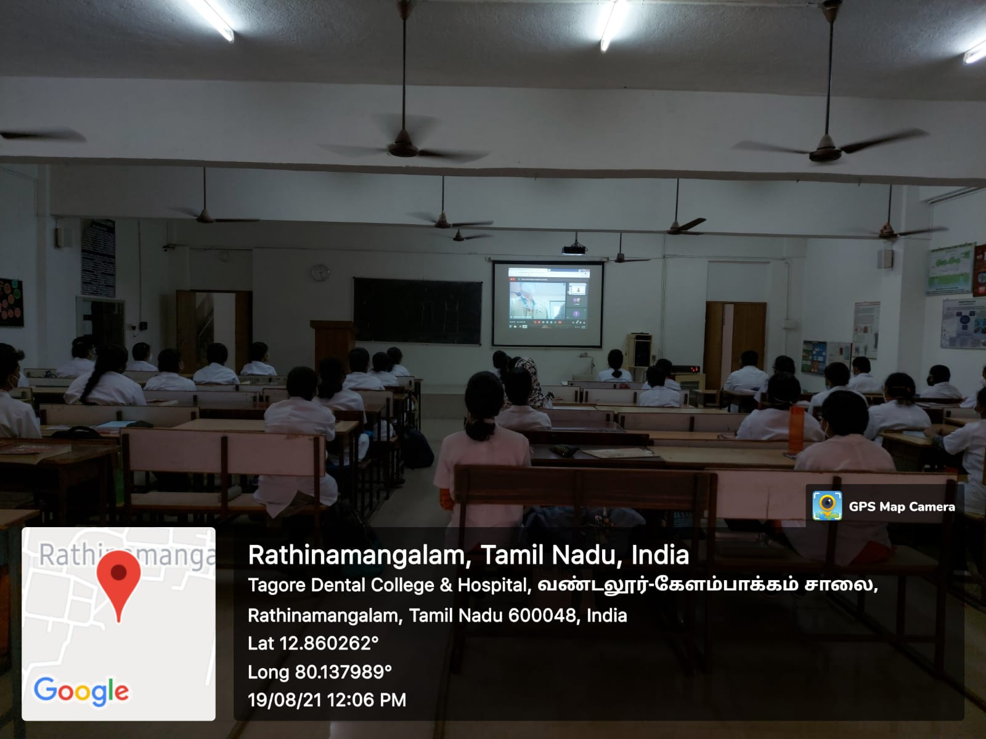
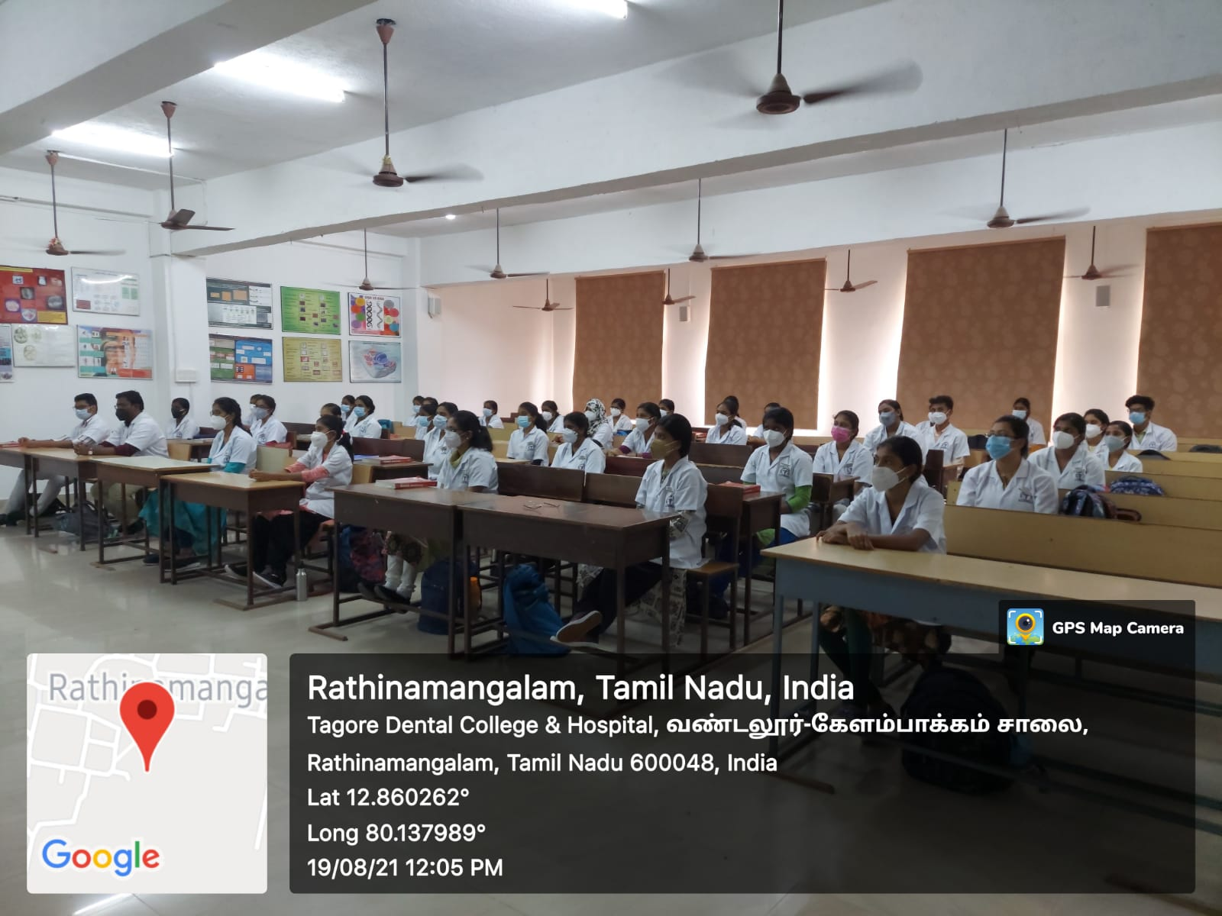
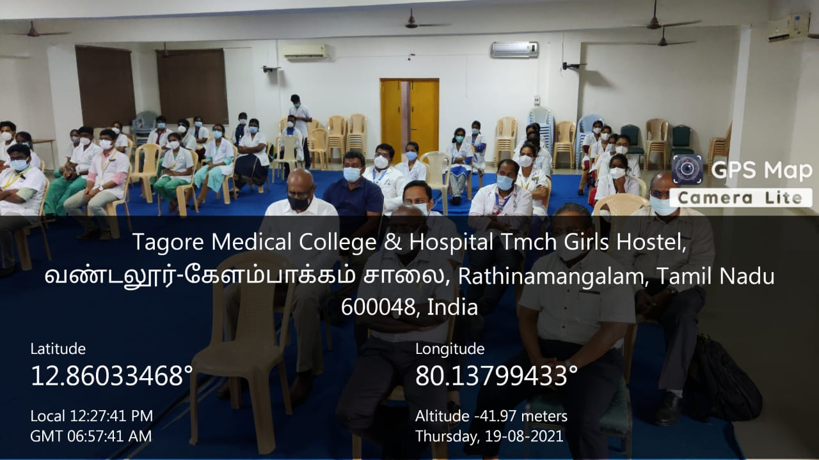
Address by the Chief guest
Audience in the classrooms in Google meet projection
Audience in the classrooms in Google meet projection
Audience in the auditorium

